Câu 1.
(3 marks) You have main function which is saved on folder named Q1 already. Use these classes and functions to test all your operations in this question, DO NOT EDIT ANY CODE in main function. You can add more operations/classes/interfaces to be able to answer the below question.

Design and code a class named Motor that holds information about a Motor. Information of a Motor includes:
- A string describes the brand name of a Motor.
- A double value describes price of a Motor.
Include the following member functions in your design:
- Constructors to set values for instance variables.
- Add needed operations to the class.
Design and code a deriving class named VNMotor from Motor class that holds information about a VNMotor. Information of a VNMotor includes:
- A String describes the series of a VNMotor.
Include the following member functions in your design:
- Constructors to set values for instance variables.
- Add needed operations to the class so that the main function can be run and complete the below method which is declared in VNMotor class, the function will be used in second test case.
  - double getSalePrice() – use to determine sale price of a Motor, sale price = original price – discount, where:
    - discount = 5 percent out of original price if original price < 3000.
    - otherwise discount = 10 percent out of original price.
Do not format the format the result.
The program output might look something like:

No of test case | Correct output | Correct output
2 | 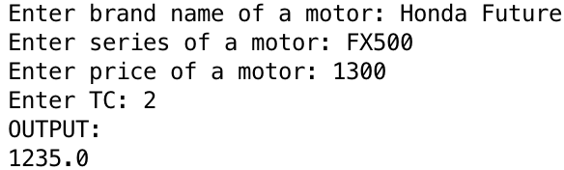 | 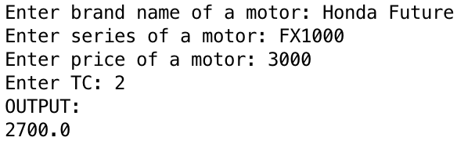
1 | 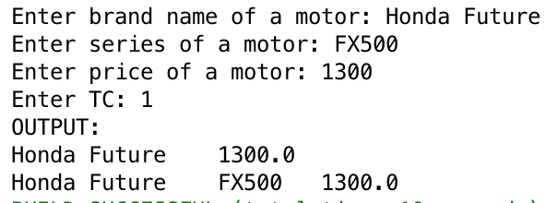

Câu 2
(4 Point) You have main function which is saved on folder named Q2 already. Use these classes and function to test all your operations in this question, DO NOT EDIT ANY CODE in main. You can add more operations/classes/interfaces to be able to answer the below questions.
We had provided you:
1. Interface – IPrinter which will declare some operations for Printers – DO NOT EDIT this one.
2. You only need to complete the code in class MyPrinter and Printer.
Design and code a class named Printer that holds information about a Printer. Information of a Printer includes:
- A double value holding price of a Printer.
- A string describing name of a Printer.
Include the following member functions in your design:
- Constructors to set values for instance variables.
- Add needed operations to the class so that the main function can be run and complete the function
  - String getName() – return name of a Printer.
Design and code a class named MyPrinter which will implement interface IPrinter and complete 2 methods which were declared in IPrinter:
- void f1(List<Printer> a, double price) – remove from the list of printers "a" all printers which has price less than or equals to given price.
- int f2(List<Printer> a, String name) - count and return number of printers which are in the list “a” and has name contains given name. The comparison must ignores the case during comparison.

Given some data which is added to list “a” in the Main already:

Printer name | Printer price
HP 200J | 110
HP 2000G | 150
Canon G1240 | 120

By using given data, the program output might look something like:

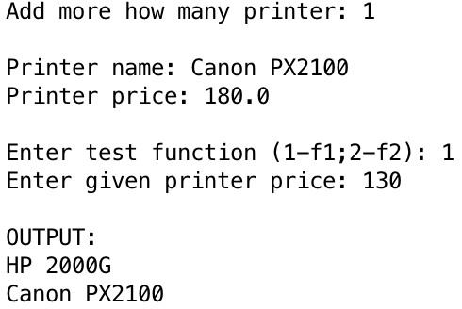 | 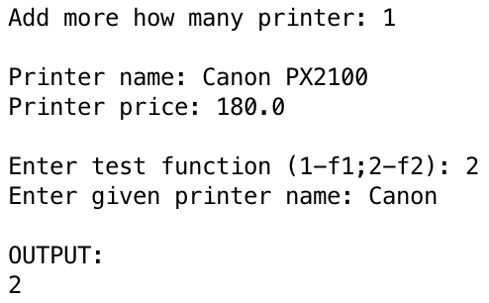

Câu 3.(3 Point) You have main function which is saved on folder named Q3 already. Use these classes and functions to test all your operations in this question, DO NOT EDIT ANY CODE in main function. You can add more operations/classes/interfaces to be able to answer the below question.

Design and code a class named ReservationCode that holds information of a ReservationCode (RC) for a customer, including:
- A string describes value of a customer name.
- A string describes value for a RC.
Include the following member functions in your design:
- Constructors to set values for instance variables.
- Add needed operations to the class and complete below method which is declared in ReservationCode class, the function will be used in the second test case.
- String getCode() – assuming that length of Reservation code is dividable by 2 ; this function return code of RC as the rule:
  - Code of RC = separate a RC into groups, each group has exactly 2 characters with same order of orginal RC, groups are seperated by character “-“, eg A1-BE-CM
The program output might look something like:

No of test case | Correct output
2 | 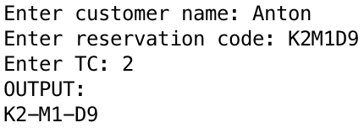
1 | 